Fire Chief’s Report
June 15th, 2023
- Operations.
- Incidents:
- (12) Med (0) Invest (1) MVA (0) g.fire (0) WBC (0) s.fire– (since last report)
ii. (27) Med, (13) G. Fire, (1) WBC, (6) S. Fire, (5) MVA, (1) Invest (year to date)
- (54) calls total for 2023

Training:
- The first Thursday of month Clinton Fire is doing training with a lot of us in Henry county. Going over somethings out of basic fire and asking us what else we can do together to help each other out.

- Change:
- Have SOP Written up and need the board and Lawyer go over.

- Vehicle/Equipment Maintenance / Radio’s:

- Brush truck #2 is still not running!!! I say we take it to a chevy dealer and just get it done and change the oil and have it serviced to while there.
- Brush truck #3 new battery’s have been put in.
- Brush truck #1 oil dipstick has been fixed and oil has been changed needs breaks and rotors.
- I would like to buy $1,000.00 worth of tools at the station so we can work on things with out running back and forth to one house.
- I have a guy that is from Calhouns Fire Department that works on apparatuses at Frontline Fire and Equipment.( Kevin Webber ) he said he would help us out fixing and get us what we need for it with the help of David and a few others to turn wrenches.
- Rest of trucks are running but going to change oil and service them one at a time.
- Accidents/Work Comp. & Claims/ Near misses:
- ( 0 ) Work Comp. Near misses (0).
- Major Activities.
- Community/Public relations:

- Media Relations: None
- Facebook: Reach 1.2 K up 33%: Post Engagement 871 up 59%: New Followers 5
- Special Projects
- Open house fundraiser – Breakfast or lunch to raise money for a new brush truck or pumper for coal station.
- .
- .
- .
- Inter-governmental:

- Administration.
- Building and Grounds ( including radio towers )
- I have no update on with the new tower yet. Just waiting for A&W to call for they are working on other towers in the county.

- Computer and Telephone Systems
- Highspeed is hooked up and Rocket Connect items has been taken in to them by me ( Chief Chuck W)

- For Consideration by the Board
- Policy changes:
- .
- .
- .
- Purchases/Contracts
- Purchased 6 AED Pads from Bonn Tree
- We had a $500.00 donation here back last month, I would like to purchase a portable suction devise with hoses and Yonkers. Will have prices for the meeting.
- We bought 10 SCBA tanks/ with packs, a box full of gloves ( around 15 ) pairs along in box we romax hoodies to put on head, and 2 bunker pants with 2 bunker coats.
- Personnel recommendations
- Employment - No new hires
- Promotion/Demotion/other Changes requiring Board approval – YES I need to have a close session and there are members that want a group one!! The Award we all got back a few months ago 1 person that was on calls never gotten his!!
- Discipline – Need to talk in close meeting
- Resignations/Terminations – UKNOWN

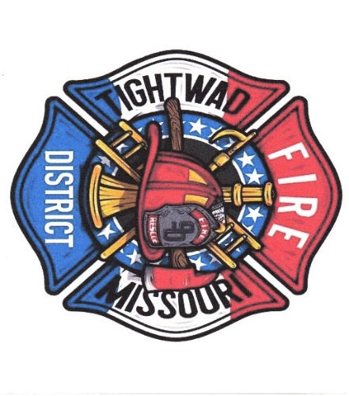
Chief Chuck Willis ( 750 )
Tightwad Fire PD
Station: 1-660-477-3456
Cell: 1-660-723-5373
Email tightwadF.D@outlook.com

Here to Protect and sever our Community In Hard Times

