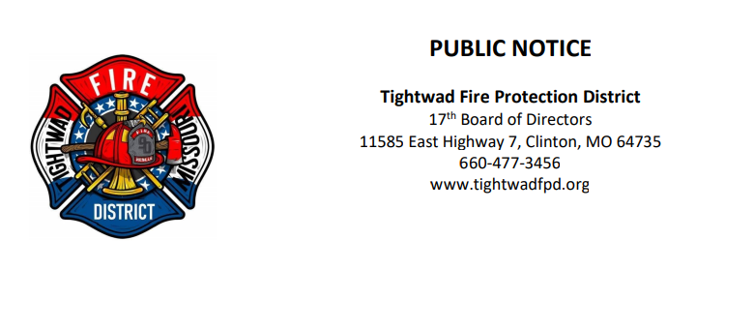

The 17th Board of Directors of the Tightwad Fire Protection District will meet:

Tightwad Fire Protection District
^{9th} Meeting of the 17th Board of Directors
Tuesday, August 22, 2022, at 7:45 pm
Souls Harbor Worship Center
1151 SouthEast Highway 7, Clinton, MO 64735
660-477-3456
www.tightwadfpd.org

