Fire Chief’s Report
February 16th, 2023
- Operations
- Incidents
i. (3) Med (1) Invest (3) MVA – (since last report)
ii. (0) Med (0) G. Fire (0) WBC (0) S. Fire (0) MVA (0) Invest (year to date)
iii. “2021” calls (143) “2022” calls (102) (41) calls less then “2021”

Training
- (4) Have pasted EMR Class that was put on by Clinton Fire Department ( Nate K, David N, Rob N, and I (Chuck)
- On February 4th-5th 2023 Winter Fire School in Columbia. Josh K. and Jimmy A. went to.
- In September on the 5th Clinton Fire has Invited us to participate in Firefighter 1 & 2. I would like to make it a MANDATORY for all volunteer’s of Tightwad Fire PD, but we need to make sure we can man the district too!
- Conservation is putting on classes on how to fight Wildland Fires. There was one in Windsor, Clinton at the Benson Center on the 15th and there is one in Montrose at the VFW Hall on the

- Change
- Working on Standard Operating Guidelines/Procedures, plus we will be getting new updated Policies we follow from Golden Valley Medical Hospital Director.

- Vehicle/Equipment Maintenance / Radio’s
- I have some quotes on the cost for putting in new valve repair kits and I have what new valve’s will cost from Fire Master Fire Equipment.
- Brush Truck #2 the last time I know of there was more the glow plugs and fuel pump done to the truck.
- Brush Truck #3 the batteries need to be replaced and it will cost $600-$750 Per battery. I ask that we buy them and get the truck running
- Tanker #2 needs to be welded around the main valve coming out of tank its leaking. I was told ( Josh K. ) that it could cost $450-$650. Quote from Custers Welding in Clinton.

- Accidents/Work Comp. & Claims/ Near misses.
- ( 0 ) Work Comp. Near misses (0).
- Major Activities
- Community/Public relations
- Chamber commerce holds a meeting every Tuesday and Thursday at 9 AM. We need to start going to….Board members and Chain of Command if they are not working.
- Media Relations
- Facebook New page likes up 50% (6) Post Reach 1311 down 21% Post Engagement 567 up 139%.
- Special Projects
- NONE.
- .
- .
- .
- Inter-governmental
- Every month 911 board members hold a meeting would like to have a Board member to come to these meetings with me so you understand what is going on.
- There is a Chief’s meeting held at the Benson Center. ( I missed this months meeting) would be a good thing for Board members to go too.
- I have not been to a Sheriff’s meeting but we should start going.
- One thing I would like seen done is that the board members and I go to the other Fire Departments in and around us Meetings and see If we can get Mutual Aid Agreements with them. ( If they want one bring the paper work with so ready to have signed)
- Strategic Planning
- A key project I would like to see is that we get with the Water District and see if we can have a fill station at the Leesville water tower. It would sure help cute filling tankers time down for time is a lot when fighting a fire.
- One more thing on water if we could the Corp. Engineers to help us get dry hydrants down at the Bucksaw Marina and down by Windsor crossing would be great for the district for ISO would look at that and give us paints to Help lower the communities Insurance ( happy people will give in return maybe to)
- Administration
- Building and Grounds ( including radio towers )
- We to check with A&W Communication to set up maintenance on the Repeater and antenna.
- Henry County Dispatch will be putting up a new tower up by the water tower just outside of Tightwad. I Have been doing some work with them to help the Fire District has better Radio signal in and around us. They said that we can do that so, I will set up a time we can meet with them to get Ins and outs of what is all involved.
- We have been given outside yard lights to put up if I can’t get the volunteers to do it we need to look at hiring someone to do that for us so it is done.
- We need to think about running airlines in the stations to hook up the trucks that have airbrakes on them along with that run more electrical outlets in the stations so we don’t have to run long cords from just a hand full of outlets this building has.
- Computer and Telephone Systems
- I don’t know of any software/virus updates need to be, but I don’t know if this where I should talk about this. I was shown a App that is just about like the Active 911 each volunteer has on their phone, It was called Iamrespond.com It does way more than the App we have like it will keep track of the maintenance of all apparatus we work on, it keeps take of everyone’s training time for them. Ect; It sure would help free time up at the end of the year for ISO reporting were I wont have tons of time sheets to go through. Highly recommend.
- I would like to change Internet to the Highspeed that is going in but need to check on prices before we do.
- For Consideration by the Board
- Proposed policy changes.
- .
- .
- .
- Purchases/Contracts
- I purchased 2 flashlights for traffic and also a set of spanner wrenches . Josh and I bought a helmet light each for we owe $80.00 a piece which I have to give to the treasurer.
- Personnel recommendations
- Employment - No new hires
- Promotion/Demotion/other Changes requiring Board approval – That is for a close meeting .
- Discipline –

- Resignations/Terminations – I will have Jeffrey Hunts Letter of Resignation typed and given to him by this meeting. Done and in file.

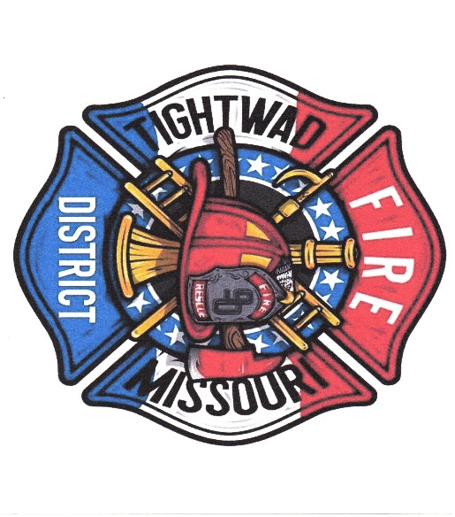
Chief Chuck Willis ( 750 )
Tightwad Fire PD
Station: 1-660-477-3456
Cell: 1-660-723-5373
Email tightwadF.D@outlook.com

Here to Protect and sever our Community In Hard Times

