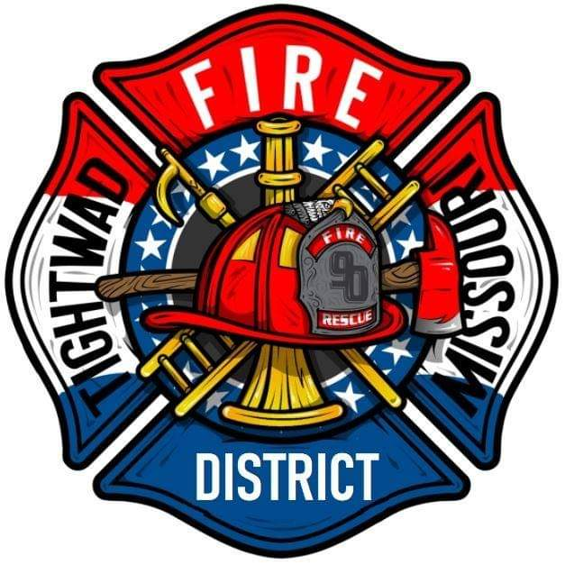 | AGENDA  Tightwad Fire Protection District  Meeting of the 17th Board of Directors  Wednesday, January 04, 2023, at 6:00 pm  Tightwad Fire Station  11585 MO Highway 7, Clinton, MO 64735  660-477-3456  www.tightwadfpd.org

- Call to order by the Chair
- Discuss Sunshine laws
  - How public can request records
  - Audio/Video/Photography of Meetings
  - Director chair attendance fees
  - Go over standing rule #007
- Chief presents
  - Where he sees the department in 10 years and how to get there
  - Departments needs

- Adjourn to Closed Meeting
  - Legal
- Adjourn to Open Session

- 4 Adjourn

