Fire Chief’s Report
March 16th, 2023
- Operations
- Incidents
i. (4) Med (0) Invest (0) MVA (4) g.fire (1) WBC (1ma) s.fire– (since last report)
ii. (4) Med (4) G. Fire (1) WBC (1) S. Fire (0) MVA (0) Invest (year to date)

Training
- None at this time!

- Change
- Working on Standard Operating Guidelines/Procedures, plus we will be getting new updated Policies we follow from Golden Valley Medical Hospital Director.

- Vehicle/Equipment Maintenance / Radio’s

- Brush Truck #2 – still not running waiting for B&B to call me back if they would look at it and if not going to see if the shop in Garden City will look at it.
- Brush Truck #3 – would like for you to approve me getting the right batteries!
- Tanker #2 needs to be welded around the main valve coming out of the tank. Bryce Cole will weld it for us. He is going to school for welding in Sedalia.

- Accidents/Work Comp. & Claims/ Near misses.
- ( 0 ) Work Comp. Near misses (0).
- Major Activities
- Community/Public relations
- None
- Media Relations
- Facebook New page likes up 71%(2) Post Reach 444 down 66% Post Engagement 116 down 80%.
- Special Projects
- NONE.
- .
- .
- .
- Inter-governmental
- Would like to have a county wide fire chief’s meeting held here at Tightwad. Need to get back to talking about things going on in our county.
- Administration
- Building and Grounds ( including radio towers )
- none
- Computer and Telephone Systems
- Has the new computer been bought for the station so Board, Treasure, clerk and Chief can work off it.
- Has a printer been bought yet?
- For Consideration by the Board
- Proposed policy changes.
- .
- .
- .
- Purchases/Contracts

- Personnel recommendations
- Employment - No new hires
- Promotion/Demotion/other Changes requiring Board approval – That is for a close meeting .
- Discipline – Maybe but, we can handle tomorrow if works for Linda and one of you from Board.

- Resignations/Terminations – None

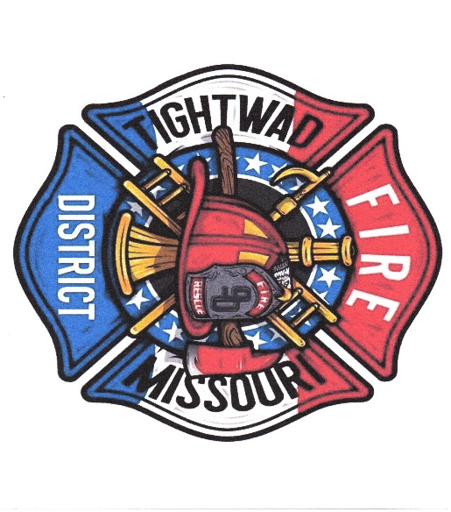
Chief Chuck Willis ( 750 )
Tightwad Fire PD
Station: 1-660-477-3456
Cell: 1-660-723-5373
Email tightwadF.D@outlook.com

Here to Protect and sever our Community In Hard Times

