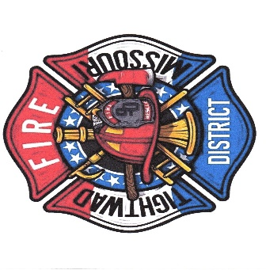
Charles Willis
Fire Chief
Tightwad, Missouri Fire PD
11585 East Highway 7
Tightwad, Missouri 6473
(O) 1-660-477-3456
(C) 1-660-723-5373

Fire Chief Report
^{September Calls}
0. Structure fire
2. Medical’s
3. Grass fire’s
3. MVA

Total volunteers- (10)

Facebook- September 19th – October 16th, 2022
Post engagements- 3220 up 300%. New page likes 21 up 133%
Training- Clinton is Having EMT class at starting January 20th for 2 weekends back to back!!!

Apparatus’s
Pumper 2. Pump test will be this week or next week will call when closer to date of doing. Also new battery’s had to be put in for 1 exploded and the rest where shot to!!!
Tanker 3. FIXED
Brush truck #2. Switching out pumps and putting in one that has more gallons per minute and more horse power.

Brush 1. Still making brackets to hold things up in back of so it is easier to garb and go plus cleaner.
Brush 4. The start is in but think we have BAD battery’s for wont start.
As for the rest of the trucks we need to start changing oil and filters here one a month or 2.
Med 1 just had done here a few months ago so wont need done till next year. Rest of the trucks are running good Just need maintenance that has been put off to long.

Hope to start working on outside lights here this week so the parking lots is lit up at night. One more thing that is going to happen is no parking on big doors. Need to thank Mary for printing them and also printed new letters for stop signs also we got 2 new signs donated to us from friend and we need a thank you card sent to him when I get Information from Rob.
CPR class went really well and thank you to some of our citizens that took the class with all the volunteers. Would like to Invite them once back to learn how to use the (LUCAS) which is an automatic device that does the compressions for you. Date is unknown

Chief Chuck Willis (750)
Tightwad Fire PD

