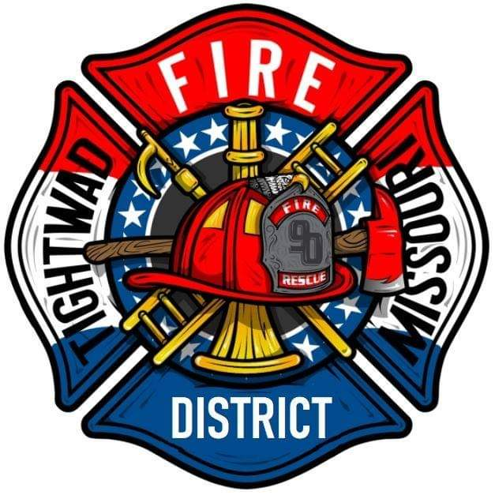 | AGENDA  Tightwad Fire Protection District  ^{11th} Meeting of the 17th Board of Directors  Thursday, Sep 29, 2022, at 6:00 pm  Tightwad Fire Station  11585 East Highway 7, Clinton, MO 64735  660-477-3456  www.tightwadfpd.org

- Call to order by the Chair
- Adjourn to Closed Session
- Closed Session-Adjourn to Closed Meeting pursuant to RSMo 610.021(1)(3)(13)
- Legal
- Resume Open Session
- Adjourn Meeting

