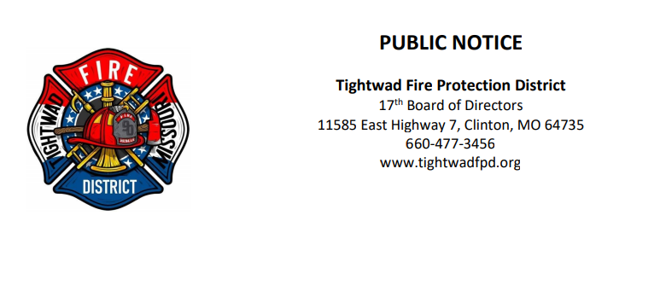

The 17th Board of Directors of the Tightwad Fire Protection District will meet:

Tightwad Fire Protection District
4th Meeting of the 17th Board of Directors
Thursday, April 28, 2022, at 6:00 pm
Tightwad Village Hall
11561 East Highway 7, Clinton, MO 64735
660-477-3456
www.tightwadfpd.org

