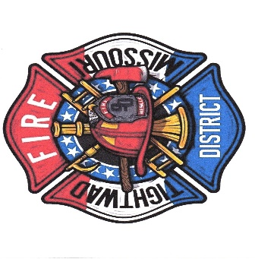
Charles Willis
Fire Chief
Tightwad, Missouri Fire PD
11585 East Highway 7
Tightwad, Missouri 6473
(O) 1-660-477-3456
(C) 1-660-723-5373

Fire Chief Report
^{October Calls}
0. Structure fire
5. Medical’s
1. Grass fire’s
2. MVA

Total volunteers- (10)

Facebook- Oct.18th to Nov 14th, 2022
Post engagements- 888 down 72%. New page like 2. down 90%
Training- waiting on date for LUCAS Training with Golden Valley

Apparatus’s
Pumper 2. Pump test will be this week or next week will call when closer to date of doing. Also new battery’s had to be put in for 1 exploded and the rest where shot to!!! Pump test was done we have valves that need replaced so waiting on price to fix.
Tanker 3. FIXED
Brush truck #2. Switching out pumps and putting in one that has more gallons per minute and more horse power. Done waiting to have insurance quote to put back on the line and check the glow plugs for hard to start

Brush 1. Still making brackets to hold things up in back of so it is easier to garb and go plus cleaner.
Brush 4. The start is in but think we have BAD battery’s for wont start.
Med 1. Waiting for a day to take into Larry at Fine Line to have painted from accident at a call.

We need to get Grants going so we can get apparatus’s to do our all’s job. Working with a guy to help us do!

Need to get a thank you card out to all that have donated items for Lake of Ozark got us 4 sections of hard suction for pumper.
Have to return a fitting I purchased from sentinel.. for the pumper #2.

Chief Chuck Willis (750)
Tightwad Fire PD

