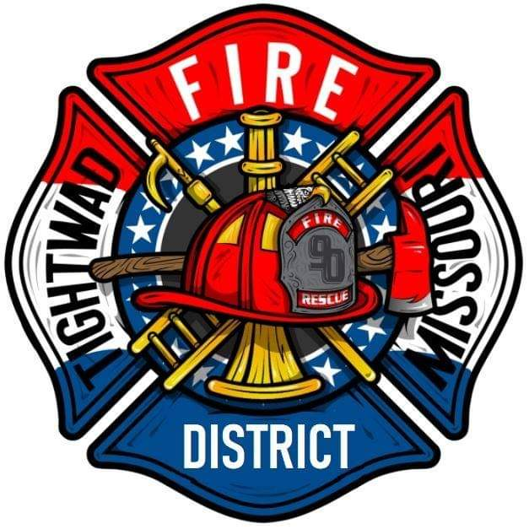 | AGENDA  Tightwad Fire Protection District  ^{14th} Meeting of the 17th Board of Directors  Thursday, March 30th , 2023, at 6:00 pm  Tightwad Fire Station  11585 SouthEast Highway 7, Clinton, MO 64735  660-477-3456  www.tightwadfpd.org
- Call to order by the Acting Chair
- Pledge of Allegiance
- Citizen Comments
- Adjourn Open Session
- Closed Session
  - Personnel 610.02 1(1)(3)(13)
  - Legal
- Adjourn Closed Session
12. Call to order – resume general session
13. Adjourn

